**_______**

# Imagen que contiene Icono Descripción generada automáticamenteUNIVERSIDAD AUTONOMA DE COAHUILA CENTRO DE IDIOMAS US



**1ST TEST**

LEVEL 3 KIDS

# STUDENT´S NAME: DATE: TEACHER´S NAME: WRITTEN GRADE ORAL GRADE

**Listening**

1. **LISTEN AND CIRCLE. ** **98**

|  |  |  |  |  |  |  |  |
| --- | --- | --- | --- | --- | --- | --- | --- |
| **1** |  |  |  | **2** |  |  |  |

|  |  |  |  |  |  |  |  |
| --- | --- | --- | --- | --- | --- | --- | --- |
| **3** |  |  |  | **4** |  |  |  |

|  |  |  |  |  |
| --- | --- | --- | --- | --- |
| **5** |  |  |  | **/10 points** |

**Vocabulary**

# LOOK AT THE PICTURE AND WRITE THE NAME.

|  |  |  |  |  |
| --- | --- | --- | --- | --- |
| **1** |  |  | **4** |  |

|  |  |  |  |  |
| --- | --- | --- | --- | --- |
| **2** |  |  | **5** |  |

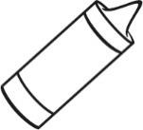**3**

**/10 points**

**Grammar**

# READ AND COLOR THE PICTURES.

* + 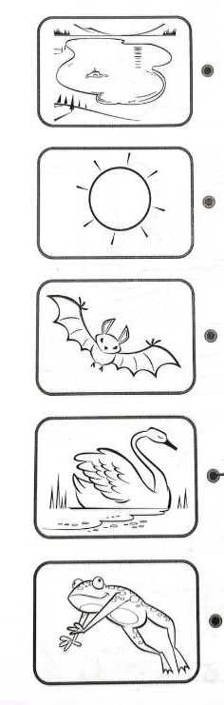It’s white
  + It’s green
  + It’s yellow
  + It’s blue
  + It’s black

**/10 points**

**Reading**

# Reading: Classroom Objects and Colors

In the classroom, there are many objects. The desk is brown, and the chair is blue. On the desk, there is a red book and a green pencil. The teacher’s whiteboard is very big and clean. The eraser is pink, and the markers are different colors: black, yellow, and purple. There is also a yellow ruler in the pencil case. The window is big and lets in sunlight, making the classroom bright and comfortable.

1. What color is the chair in the classroom?
2. What two colors are mentioned for the markers?
3. Where is the yellow ruler located?
4. What is the color of the eraser?
5. How does the window affect the classroom?

**/10 points**

**Writing**

# Write 5 sentences describing objects in your classroom.



**/10 points**

**TOTAL POINTS 50**